**How to install Power Bi Desktop**

1. Use this link to get the download:

<https://powerbi.microsoft.com/en-us/downloads/>

1. The link will direct you to this page. Click on DOWNLOAD.

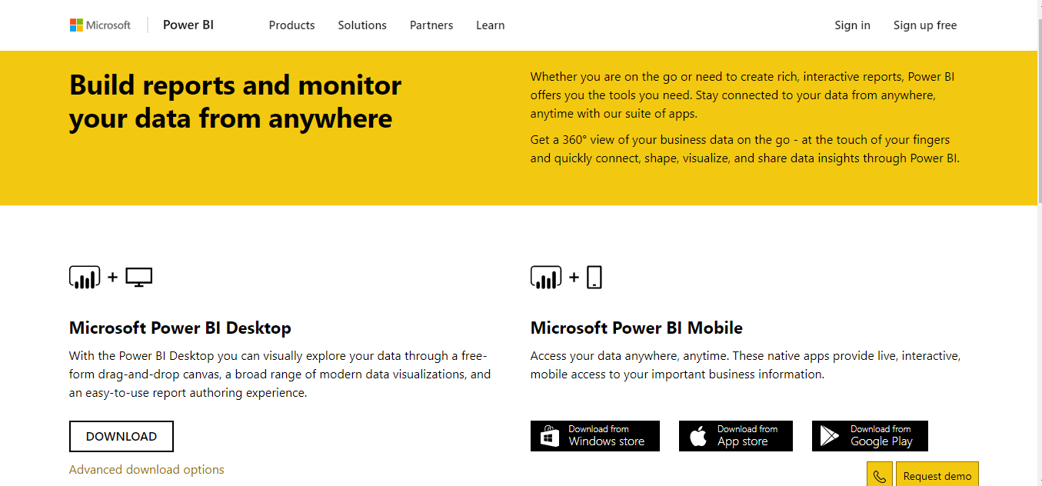

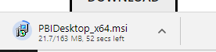

1. The installer will begin downloading.

1. After the download is finished, click on it to open up the installer.
2. Click on Next

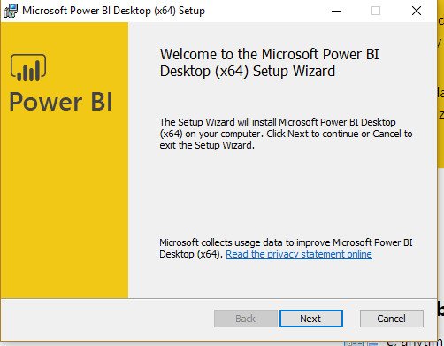

1. You’ll then see this window. You may read the terms and agreements. Then click the accept checkbox and click Next.

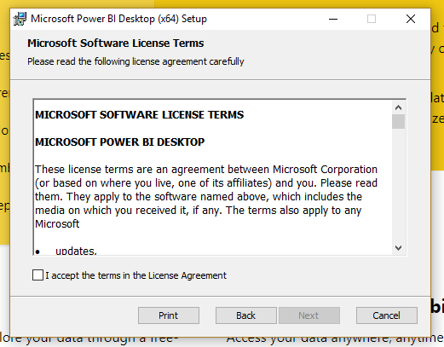

1. The installer will assign a default destination folder for the application. You may change the location if needed and click Next.

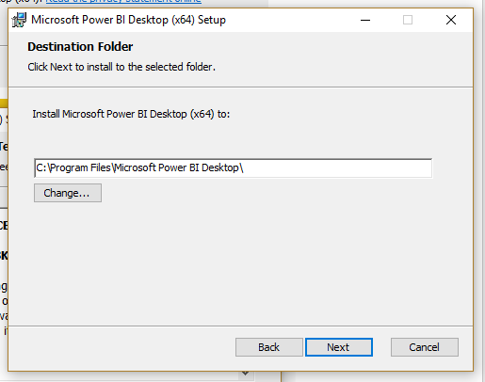

1. Click Install.

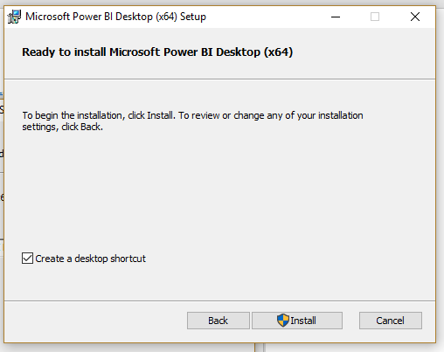

1. The installation will begin. You may be prompted to enter in admin credentials to continue the installation.

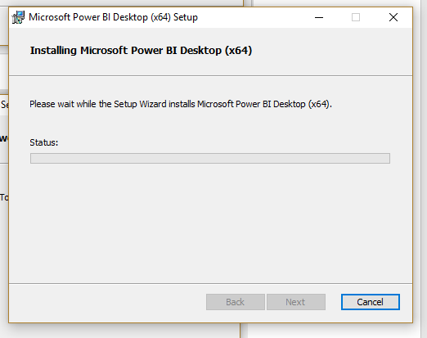

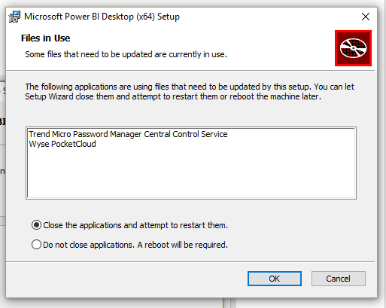

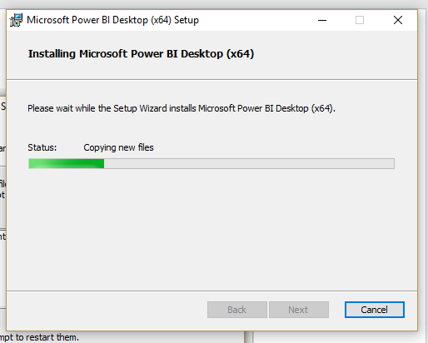

1. After the installation finishes, click Finish. This will launch Power Bi Desktop if the Launch Microsoft Power BI Desktop checkbox is clicked.

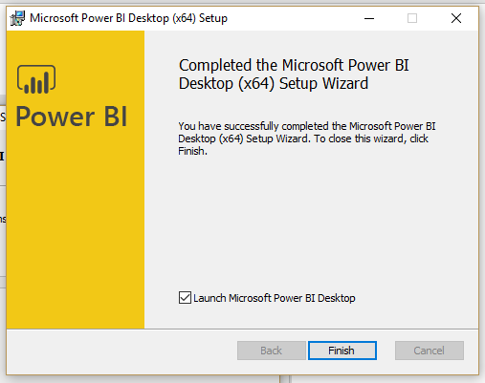

1. The application will now open and a window will open prompting you to enter in sign in information.

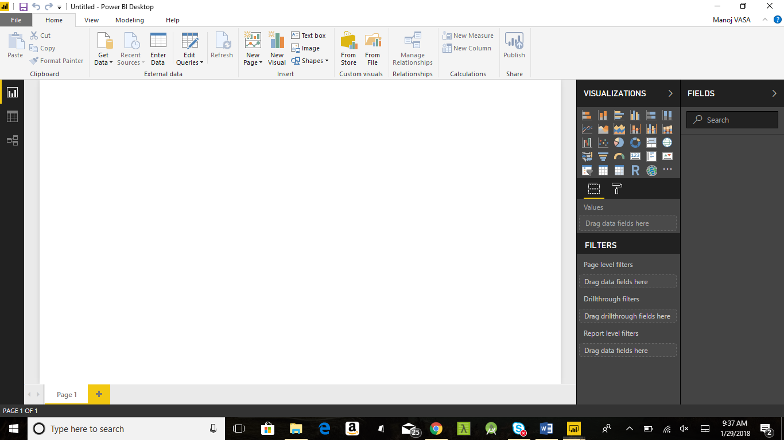

After clicking finish, the Power BI Desktop application will open and ask you enter some sign in information.

These fields will appear in a window right after the application is opened:

First Name

Last Name

Email

Country/Region

Company

Fill out this information if you don’t already have an account. If you already do have an account, sign into that one and you’re ready to use Power Bi desktop.